**CAP 276: DATA COMMUNICATION AND NETWORKING LABORATORY**

**PRACTICAL_CLASS_1.**

* **HOW TO DOWNLOAD CISCO PACKET TRACER:**

**PROCESS: -**

* Open any browser and search official website of Netacad.
* Click on first link “cisco packet tracer-Networking simulation Tool.
* 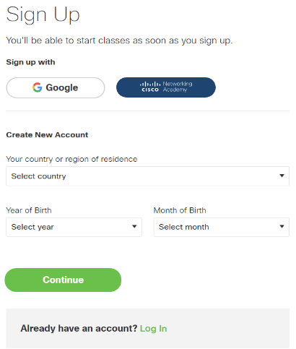Then scroll down and click on view course.
* Click on Skills For All.
* Click on Get Started.
* Then a dialog box open.
* Create an account or login with your Gmail account.
* Click on Term & condition.
* Click on download and use Cisco Packet Tracer.
* Click on view in Fullscreen.
* Then a dialog box open.

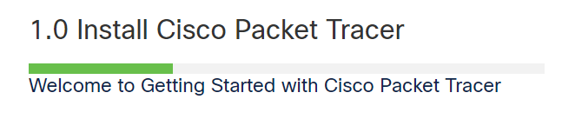

* Click on install Cisco Packet Tracer.
* Then scroll down.
* Click on Highlighted download 2nd link.
* Then will redirect to 2nd page.
* Then scroll down.
* Click on download.
* **HOW TO INSTALL CISCO PACKET TRACER:**

**PROCESS: -**

* 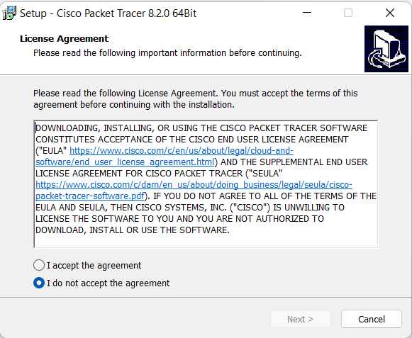Double click on downloaded file.
* Then a dialog box open.
* Check “I accept the agreement.
* Click on Next button.
* Choose the installing location as you need.
* Click on next button.
* 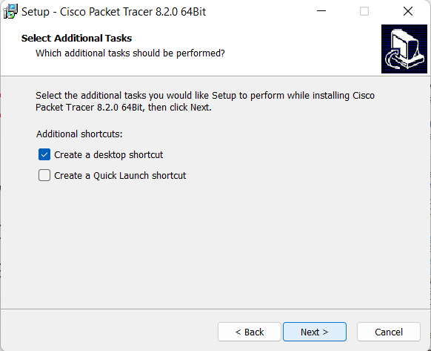Check the box “Create a desktop shortcut.
* Click on Next button.
* Again, click on install button.
* Again, click on Finish button.
* Installed Cisco Packet Tracer.



**PRACTICAL_CLASS_2.**

* **HOW TO CONNECT PEAR TO PEAR PC IN CISCO PACKET TRACER:**

**PROCESS: -**

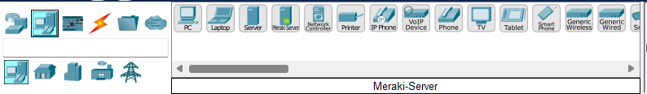

**1**

**2**

* Open Cisco Packet Tracer.
* Select computer icon.
* Again, select any pc as you need.
* Click on working area.

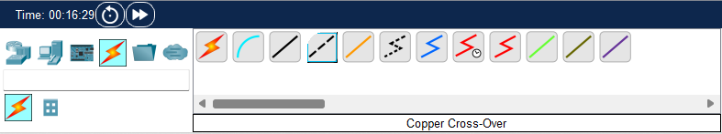

**3**

**4**

* Click on connection wire.
* Select Copper Cross-Over wire.
* Click on 1st PC then opened properties box.
* Click on fast Ethernet0.
* Draw the mouse pointer and click on 2nd pc .

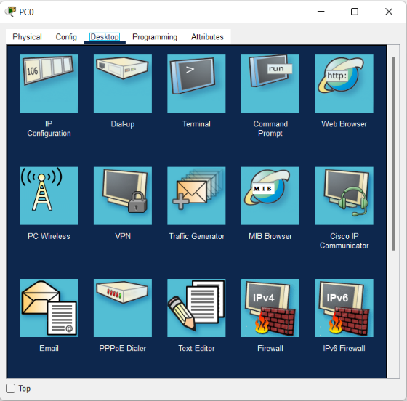

* Again, opened properties box
* Then click on fast ethernet0.
* Click on 1st PC then a dialog box open.
* Click on Desktop tab.
* Click on IP Configuration.
* Select Static radio button.
* Enter IP address.
* Press Enter key and close window.
* Again, click on 2nd PC then a dialog box open.
* Click on Desktop tab.
* Click on IP Configuration.
* 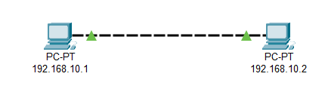Select Static radio button.
* Enter another IP address.
* Press Enter key and close window.
* Rename both PC name with IP address.
* Click on 1st PC then a dialog box open.
* 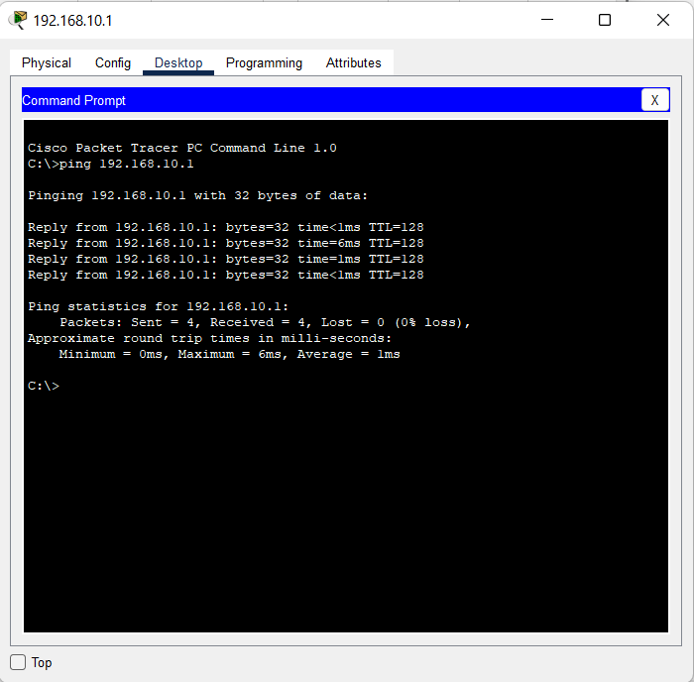Click on Desktop tab.
* Click on Command Prompt.
* Type “ping space 2nd PC IP address.
* Press Enter key.
* Successful connect and sent.

**PRACTICAL_CLASS_3.**

* **How to connect Hub to more than one PC.**

**PROCESS: -**

* 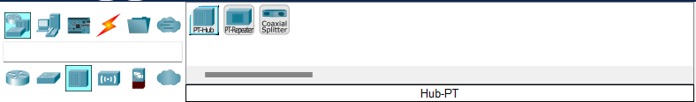Open Cisco Packet Tracer.
* Click on Hubs option.

**2**

* Select Hub- PT.

**1**

* Draw the working blank area.
* Again, click on PC icons.



**1**

**2**

* Select PC as you need.
* Draw the PC in working area.
* Click on connection wire.
* Select Automatically Choose Connection Type wire.
* Select wire. (Ctrl + left click).
* Click on Hub.



**3**

**4**

* And click on 1nd pc .
* Again, click on Hub.
* And click on 2nd PC.
* Again, click on Hub.
* And click on 3rd PC.
* Generate IP address in PC. (See process for generate IP address 1st project).
* Select PDU message box.
* Click on any one PC.
* Again, click on another PC. (For connect two or more PC in Single HUB).
* 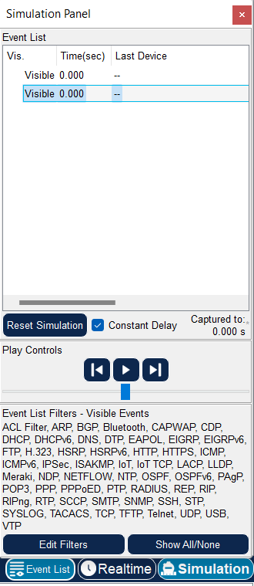click on Simulation icon.
* Then a dialog box open.
* Click on Play button.

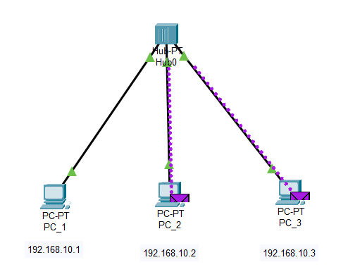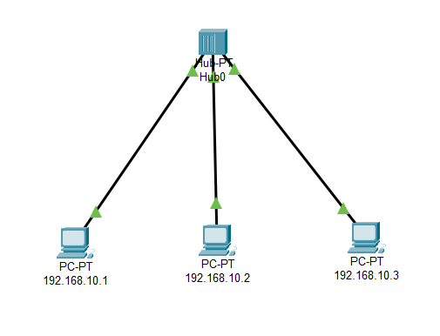

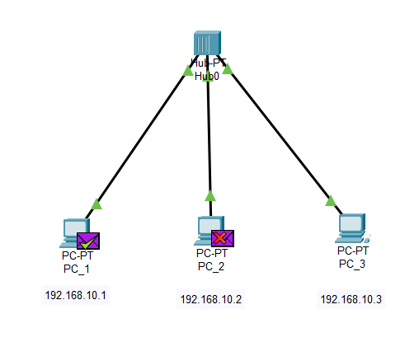

**Finally Result sent PC_1 to PC_3**

**After send PDU PC_1 to PC_3**

**Before send PDU.**

**PRACTICAL_CLASS_4.**

* **How to connect Switch to more than one PC.**

**PROCESS: -**

* 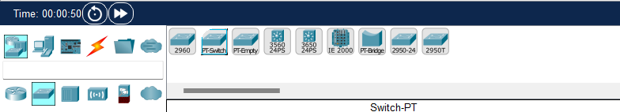Open the Cisco Packet Tracer.
* Click on Switch option.
* Select Switch- PT.



**1**

**2**

**1**

**2**

* Draw the working blank area.
* Again, click on PC icons.
* Select PC as you need.
* Draw the PC in working area.
* Click on connection wire.
* Select Automatically Choose Connection Type wire.
* Click wire. (Ctrl + left click).



**3**

**4**

* Click on Switch.
* And click on 1nd pc .
* Again, click on Switch.
* And click on 2nd PC.
* Again, click on Switch.
* And click on 3rd PC.
* Generate IP address in PC. (See process for generate IP address 1st project).
* Select PDU message box.
* Click on any one PC.
* Again, click on another PC. (For connect two or more PC in Single Switch).
* Click on Simulation icon.
* Then a dialog box open.
* Click on Play button.

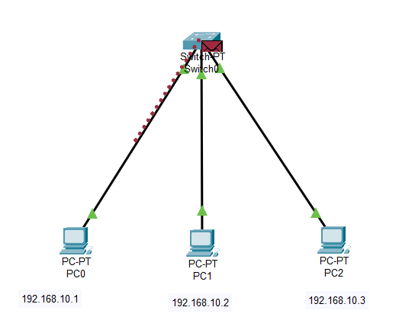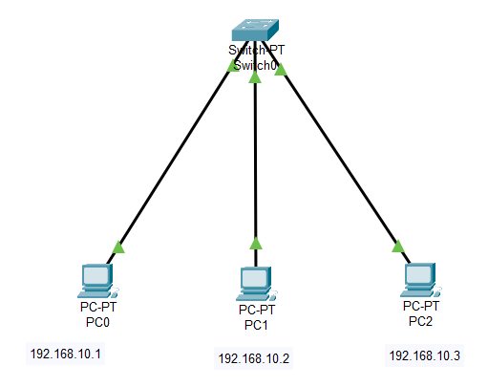

**After send PDU PC_1 to PC_3**

**Before send PDU.**

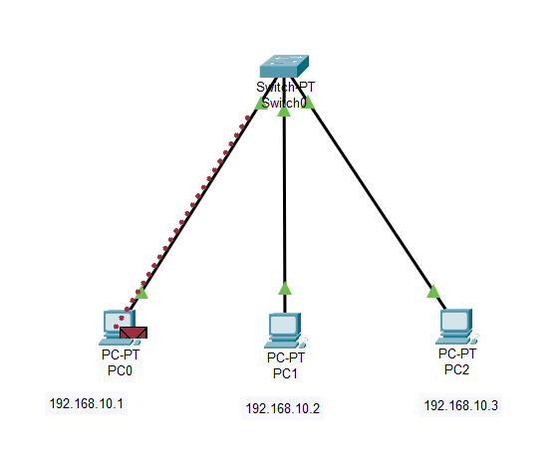

**Finally Result sent PC_1 to PC_3**